**Plot 1:**

**Unethical:**

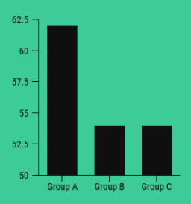

**Properties:**

1. **Ethical:** No
2. **Ethicality and Appropriateness of Elements:** No
3. **Fix it/ Avoid:** In this example, the baseline is not 0. And, it was skewed by making the baseline to 50. The graph is truncated and misleading. This makes a difference between groups and Group A is looking much larger than Group B and C combined. The graph looks dramatic and not accurate. Difficult for a user to depict the information from this chart

**Ethical:**

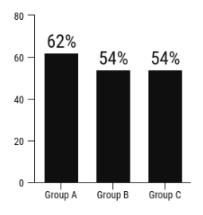

**Properties:**

1. **Ethical:** Yes
2. **Ethicality and Appropriateness of Elements:** Yes
3. **Aspects for Quality Visualization:** In this example, the plot starts from the baseline 0. It offers a more accurate depiction of the data. The difference between the groups does not seem as dramatic. The scale is also proportionate to the data

**Plot 2:**

**Unethical:**

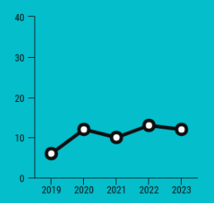

**Properties:**

1. **Ethical:** No
2. **Ethicality and Appropriateness of Elements:** No
3. **Fix it/ Avoid:** In this example, the Y-axis was tweaked with the limits of 0 to 40. The scale is disproportionate to the data, making the change over the time is seems to be small. The graph is manipulated and mislead with the Y-axis. Expanding or compressing the scale on graph can make changes in data seem more or less significant than they actually are

**Ethical:**

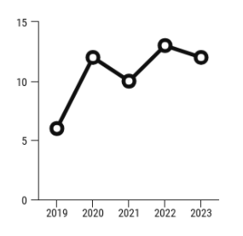

**Properties:**

1. **Ethical:** Yes
2. **Ethicality and Appropriateness of Elements:** Yes
3. **Aspects for Quality Visualization:** In this example, I looked at this dataset over the last 5 years. The data was plotted on a line graph which correlates with the time-series data. The scale is also proportionate to the data and showing a greater change over time

**Impact of Visualization on Audience and Business:**

One should follow the Ethical Attributes before manipulating the Y-axis. The vertical axis at 0 offers a more accurate illustration of the data. Cherry-picking creates a false impression of the data and the audience would be deluded. Use the right plot for the right data because they are interrelated. Maintain the Visual hierarchies and semantics. So, try to avoid these mistakes and make our data story compelling. Follow the ethical disciplines, units, scaling, graphs, and others